100  FINISH | 99 | 98  (+12) + (-20) | 97 | 96 | 95 | 94 | 93 | 92 | 91  (+8) + (-16)
81 | 82 | 83 | 84  (+7) + (-5) | 85 | 86 | 87 | 88 | 89 | 90
80 | 79  (-13) + (+14) | 78 | 77 | 76 | 75 | 74 | 73  (-5) + (+1) | 72 | 71
61 | 62 | 63 | 64  (-22) + (+24) | 65 | 66 | 67  (+4) + (+2) | 68 | 69 | 70
60  (+3) + (+1) | 59 | 58 | 57 | 56 | 55  (-2) + (-1) | 54 | 53 | 52 | 51  (-4) +(+6)
41 | 42 | 43  (-2) + (+5) | 44 | 45 | 46 | 47  (-5) + (+2) | 48 | 49 | 50
40 | 39  (-17) + (+22) | 38 | 37 | 36 | 35 | 34 | 33 | 32  (+18) +(-16) | 31
21 | 22 | 23 | 24  (-3) +(+3) | 25 | 26 | 27 | 28 | 29 | 30  (+2) + (+2)
20  (+7) + (-4) | 19 | 18 | 17 | 16 | 15  (-3) + (-2) | 14 | 13 | 12 | 11
1  START | 2 | 3 | 4  (+4) + (-2) | 5 | 6 | 7 | 8 | 9  (-5) + (-4) | 10
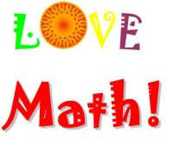
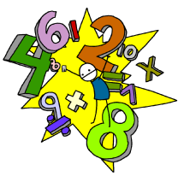
When you land on a block with an equation, calculate the answer to determine the blocks you need to move.
Move forward for a positive answer and backward for a negative answer.

